Requirements Specification for Monumental Clothing Company

Prepared By: Dangerfield, Malabanan, Saint-Amour, Wilson

Table of Contents

**Project Drivers** **4**

The Purpose of the Project 4

User Business or Background 4

Goals of the project 4

Goal Statement 4

Advantage 4

Measurement Criteria 4

**The Stakeholders** **4**

Client 4

Users 4

**Project Constraints** **5**

Mandated Constraints 5

Solution Constraints 5

Anticipated Workplace Environment 5

Schedule Constraints 5

Budget Constraints 5

**Naming Conventions and Terminology** **5**

Definition of all terms, acronyms used by the stakeholders 5

**Relevant Facts and Assumptions** **6**

Relevant Facts and Assumptions 6

Business Rules 6

Assumptions 6

**Functional Requirements** **6**

The Scope of the Work 6

Current Situation 6

The context of Work 7

Work Partitioning 8

Business Use Cases 9

**Scope of the Product** **10**

Product Use Cases 10

Functional Requirements 12

**Non-functional Requirements** **15**

Look and Feel Requirements 15

Usability and Humanity Requirements 15

Performance Requirements 15

Operational and Environmental Requirements 15

Maintainability and Support Requirements 16

Security Requirements 16

Cultural Requirements 16

Legal Requirements 16

**Project Issues** **17**

Open Issues 17

# Project Drivers

## The Purpose of the Project

### User Business or Background

Monumental Clothing Company is a clothing store headquartered in Towson MD. MCC sells its merchandise on their website and various community events and Pop-up Shops.

### Goals of the project

#### Goal Statement

* + - * 1. The aim of the project is to build a new platform for MCC to sell its merchandise. The new platform will also keep track of the inventory and provide ways for admins to update & manage said inventory.

#### Advantage

* + - * 1. The new system will be modern, easy to use and increase customer engagement.

#### Measurement Criteria

* + - * 1. MCC will measure the performance of the new system based on the KPIs that MCC uses. KPIs such as customer engagement, sales, abandoned carts.

## The Stakeholders

### Client

* + - 1. Monumental Clothing Company
      2. The customers
      3. The partners
      4. The vendors

### Users

* + - 1. The customers of Monumental Clothing Company
      2. The partners
      3. The vendors
      4. The employees
      5. The admins
      6. The managers

# Project Constraints

## Mandated Constraints

### Solution Constraints

* + - 1. Security for the project must be sufficient for customers’ data.
      2. The solution must be mobile friendly for vendors to utilize and customers to visit the site without device restrictions.
      3. The solution should provide the ability for the system to have higher traffic.
      4. The solutions must integrate with the existing ERP system.

### Anticipated Workplace Environment

* + - 1. The environment will be web-based as users utilize online sources rather than standard stores to purchase items including websites, community events, showcases, and pop-up shops.
      2. The environment will be device-independent for all users to be able to utilize the website.

### Schedule Constraints

* + - 1. The project has an expected schedule of 2 years and 10 months from the initial meeting.
      2. Within 2 months, the proposal shall be completed and provided to Monumental Clothing Company.
      3. Within 8 months, the project should begin.
      4. After 2 years of the project start date, the project should be completed.

### Budget Constraints

* + - 1. There is a $2 million budget for the project lifecycle.

## Naming Conventions and Terminology

### Definition of all terms, acronyms used by the stakeholders

* + - 1. Enterprise resource planning (ERP) is a business process management software that allows an organization to use a system of integrated applications to manage the business and automate many back-office functions.
      2. Flat file database is a type of database that stores data in a single table.

## Relevant Facts and Assumptions

### Relevant Facts and Assumptions

* + - 1. Currently, the owner and at least 3 people are employed for street vending events.
      2. The customer survey indicates that 75% would like an increase in performance when processing payments through the website and would also prefer to view the most updated inventory status of merchandise.
      3. MCC currently uses a flat-file system to record their business operations.

### Business Rules

* + - 1. Transactions will mainly be done online. Some exceptions can be made if agreed upon.

### Assumptions

* + - 1. We assume that MCC will be engaging with training future employees on system use.
      2. We assume that only a website will need to be created and that it should be mobile responsive.
      3. We assume that current data must be migrated to the new system; data will be handled as vigilant as possible and is subject to approval.
      4. We assume that security measures will need to be taken into account; Subjects such as Cross-Site Scripting (XSS), SQL injection, and Cross-Site Request Forgery (CSRF) will be addressed during the development of this project. All other types of security vulnerabilities will be handled by the client’s cloud hosting services.
      5. We assume that the system will need to interface with an existing ERP system.
      6. We assume that the system will need to interface with popular payment services such as PayPal and Venmo.

# Functional Requirements

## The Scope of the Work

### Current Situation

* + - 1. Currently, the system allows for potential customers to view the content of Monumental Clothing and uses a flat-file system for the managers and owners to manage their business operations. The current system lacks the ability for customers, if not registered as a member, to place orders, does not possess the ability to send alerts and coupons to registered members, does not have the ability to connect to the kiosk in-store.

### The context of Work

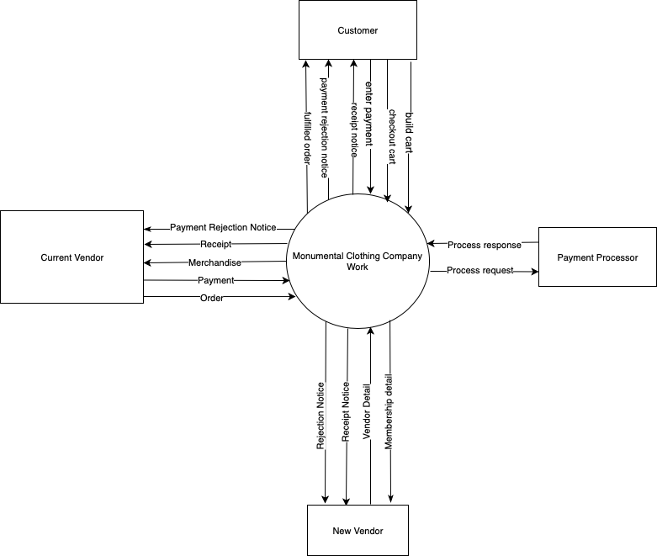

* + - 1. The context of this work is to update the current system being used by Monumental Clothing. The system is a web-based system for customers, vendors, the owner, and management to purchase and keep track of clothing. The purpose of this updated system is to include more easy to use options and address user wants and concerns of the current system. In the end, this system should provide all users with an easy, simple, and comfortable experience.

### Work Partitioning

|  |  |  |  |
| --- | --- | --- | --- |
| **Business Event Name** | **Data Inflow/Outflow** | **Adjacent systems Involved** | **Business Use Case Name** |
| New vendor application | Vendor Detail(in),  Receipt Notice(out),  Rejection Notice(out),  Membership Detail(out) | New Vendor | New vendor processing |
| The customer makes a new order | build cart(in),  checkout cart(in),  enter payment(in),  Process request(out),  Process response(in),  receipt notice(out),  payment rejection notice(out),  fulfilled order(out) | Customer  Payment Processor | Customer new order process |
| Current vendor order needs processing | Order(in),  Payment(in),  Process request(out),  Process response(in),  Receipt(out),  Payment rejection notice(out),  Merchandise(out) | Current Vendor,  Payment Processor | New order processing |

### Business Use Cases

* + - 1. New vendor processing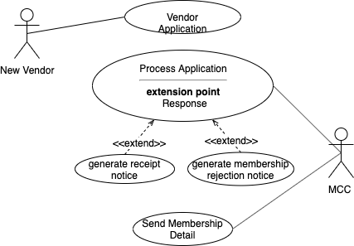
      2. Customer new order process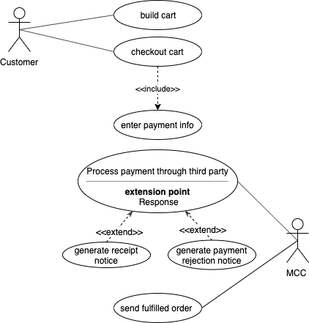
      3. New order processing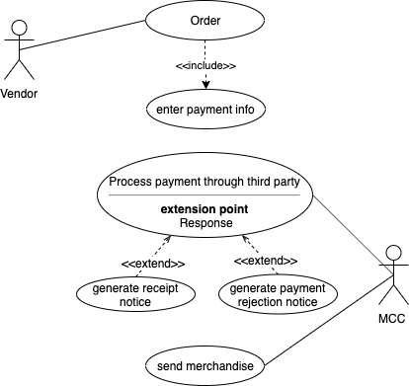

## Scope of the Product

### Product Use Cases

* + 1. Customer Ordering
       1. Product Use Case Name: Customer Ordering
       2. Trigger: User/Vendor submits a new order
       3. Preconditions:
          1. User/Vendor must have already built a cart
          2. User/Vendor must have already entered their payment information
       4. Interested Stakeholders: Customers, vendors, MCC
       5. Actor: Customer/Vendor

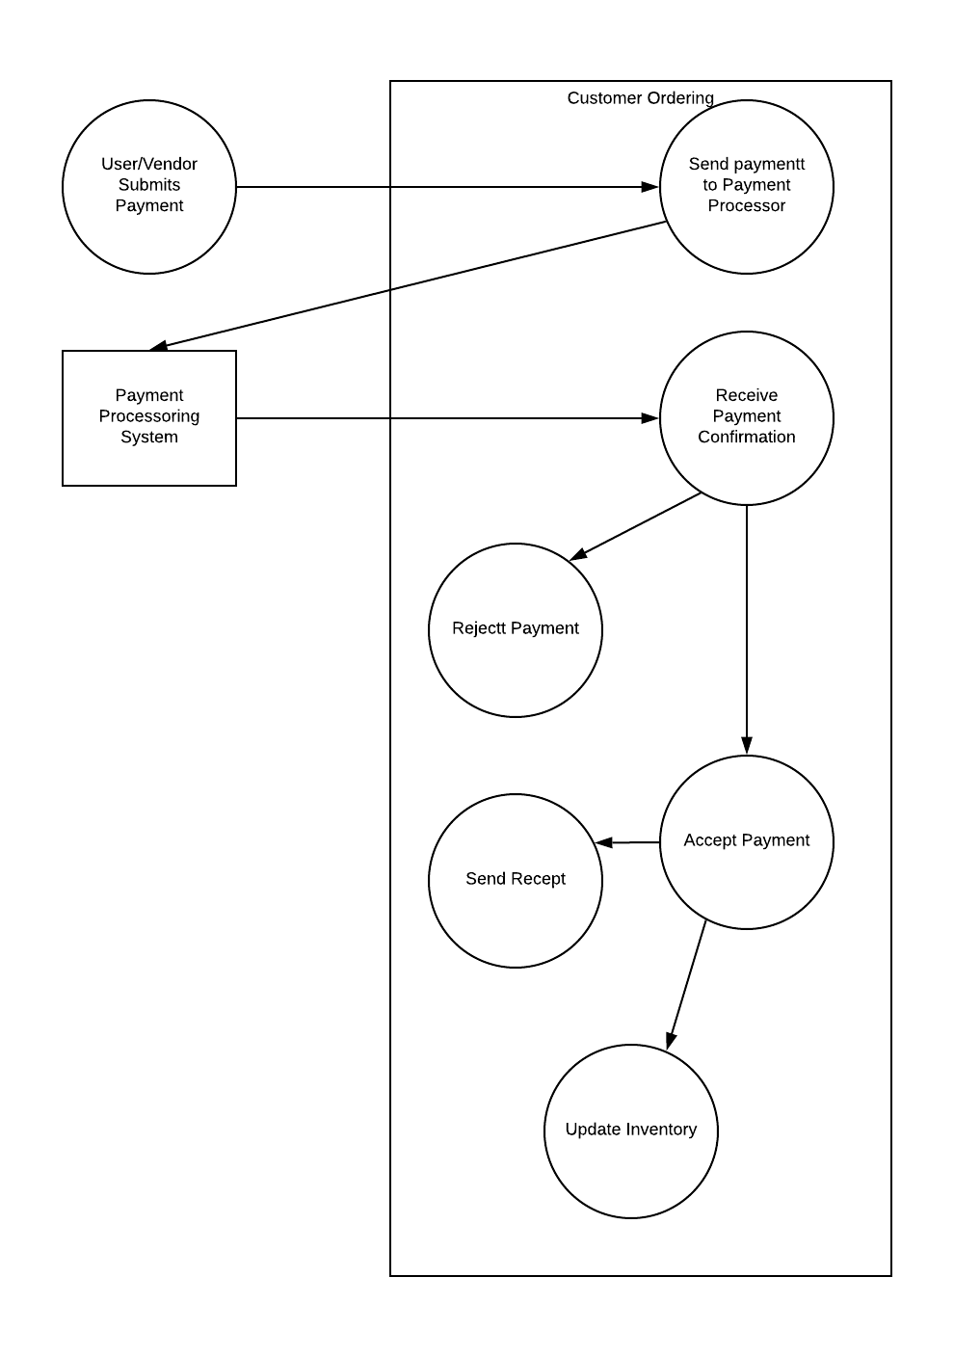

* + 1. Registration
       1. Product Use Case Name: Vendor applying
       2. Trigger: Vendor submits a new application
       3. Preconditions:
          1. The Vendor has already completed the application
       4. Interested Stakeholders: Vendors, MCC
       5. Actor: Vendor

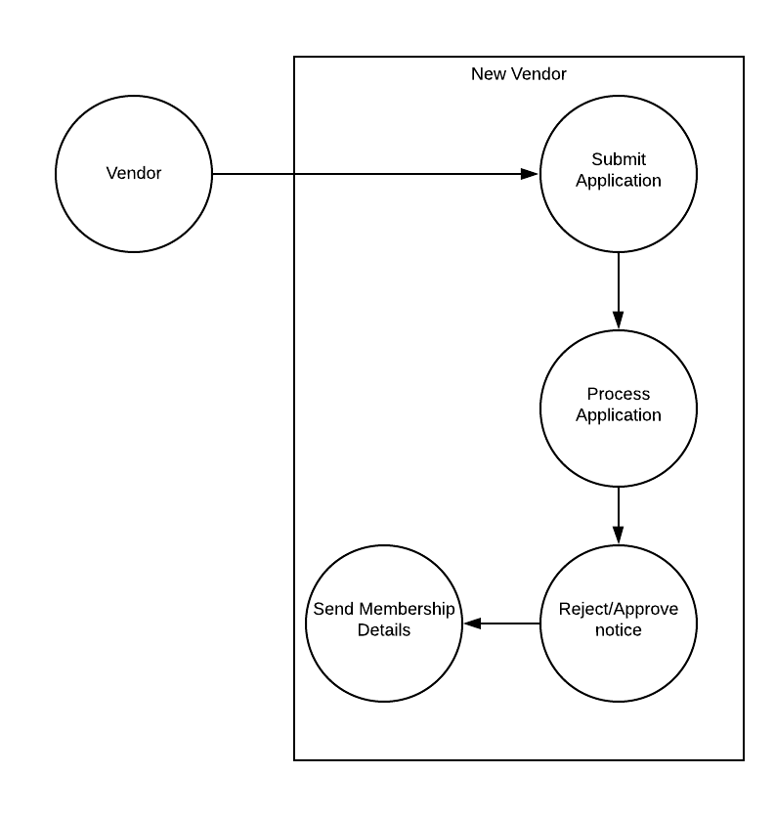

### Functional Requirements

* + 1. **New vendor processing**
       1. Vendor Application
          1. **Description:** New vendor submits an application
          2. **Rationale:** The vendors will need to submit a membership
          3. **Fit criteria:** New vendor shall have the option to become a vendor
       2. Receive their receipt notice
          1. **Description:** After submitting an application, vendors should have a receipt for their membership
          2. **Rationale:** This allows the vendors to have documentation of their new membership
          3. **Fit criteria:** Vendors shall receive an email receipt that details their membership
       3. Receive their membership rejection notice
          1. **Description:** The vendor should receive notice when their application gets rejected
          2. **Rationale:** Inform vendor application was rejected
          3. **Fit criteria:** Vendors shall receive a message stating their application was rejected
       4. Receive their membership details
          1. **Description:** After new vendor application has been processed, the new vendors should receive membership details
          2. **Rationale:** Allows vendors to receive membership details
          3. **Fit criteria:** Vendors shall receive their membership details
    2. **Customer new order process**
       1. Build their cart
          1. **Description:** A customer adds or deletes items to their cart in order to start an order
          2. **Rationale:** The cart will allow customers to collect items for their order and review those items before placing the order
          3. **Fit criteria:** Customers cart shows their added items and removes their deleted items
       2. Checkout their cart
          1. **Description:** After building a cart the customer will review their order and then place their order
          2. **Rationale:** All stores need a checkout functionality
          3. **Fit criteria:** Customers can submit their orders successfully
       3. Enter their payment
          1. **Description:** As part of the checkout process customers can enter their payment information and they should also have the option to save that info for future orders.
          2. **Rationale:** Entering payment will allow the customer to pay for the items in their cart and allows the company to receive their payment.
          3. **Fit criteria:** Customers can input the numbers and characters associated with their card including the card number, expiration date, security code, and name on the card.
       4. Receive their receipt notice
          1. **Description:** After submitting orders, customers should have a receipt for their purchase
          2. **Rationale:** This allows for the customer to have documentation of the order they placed and items they should expect to receive.
          3. **Fit criteria:** Customers shall receive an email receipt that details the items they purchased.
       5. Receive their payment rejection notice
          1. **Description:** When a payment fails a customer should receive notice that the payment failed and be provided with the option to change their payment method
          2. **Rationale:** This prevents customers from entering incorrect or fake payment information. This allows for customers to be notified their payment information was not accepted.
          3. **Fit criteria:** Customers shall receive a message stating their information was incorrect and payment was not accepted.
       6. Receive their fulfilled order
          1. **Description:** After an order has been processed customers should receive their orders
          2. **Rationale:** Allows customers to receive the items they purchased.
          3. **Fit criteria:** Customers shall receive the items on their receipt and paid for.
    3. **New order processing**
       1. Order
          1. **Description:** Vendor places an order to restock items on their inventory
          2. **Rationale:** The vendors will need to restock their inventory
          3. **Fit criteria:** Vendor shall have the option to reorder items
       2. Enter their payment
          1. **Description:** As part of the checkout process vendors can enter their payment information and they should also have the option to save that info for future orders.
          2. **Rationale:** Entering payment will allow the vendor to pay for the items in their cart and allows the company to receive their payment.
          3. **Fit criteria:** Vendors can input the numbers and characters associated with their card including the card number, expiration date, security code, and name on the card.
       3. Receive their receipt notice
          1. **Description:** After submitting orders, vendors should have a receipt for their purchase
          2. **Rationale:** This allows for the vendor to have documentation of the order they placed and items they should expect to receive.
          3. **Fit criteria:** Vendors shall receive an email receipt that details the items they purchased.
       4. Receive their payment rejection notice
          1. **Description:** When a payment fails a vendor should receive notice that the payment failed and be provided with the option to change their payment method
          2. **Rationale:** This prevents vendors from entering incorrect or fake payment information. This allows vendors to be notified their payment information was not accepted.
          3. **Fit criteria:** Vendors shall receive a message stating their information was incorrect and payment was not accepted.
       5. Receive their fulfilled order
          1. **Description:** After an order has been processed vendors should receive their orders
          2. **Rationale:** Allows vendors to receive the items they purchased.
          3. **Fit criteria:** Vendors shall receive the items on their receipt and paid for.

# Non-functional Requirements

## Look and Feel Requirements

* + 1. Appearance Requirements
       1. **Description:** The product shall be attractive to the target audience and comply with corporate branding standards.
       2. **Rationale:** To ensure that the appearance of the product conforms to the organization’s expectations.
       3. **Fit Criterion:** Monumental clothing company shall validate if the product complies with its standards.

## Usability and Humanity Requirements

* + 1. Easy to use:
       1. **Description:** A user-friendly & straightforward checkout process
       2. **Rationale:** Research has shown that lots of carts are abandoned because of unfriendly & difficult checkout experiences.
       3. **Fit Criteria:** A one-click straightforward and easy checkout button

## Performance Requirements

* + 1. Speed
       1. **Description:** The system shall be fast and responsive with little to zero lag and loading times.
       2. **Rationale:** To ensure that the product is able to perform in a fast-paced environment.
       3. **Fit Criterion:** No response shall take longer than 2.5 seconds. Loading times for each screen be less than 3 seconds.

## Operational and Environmental Requirements

* + 1. Training:
       1. **Description**: We want our employees to be able to get familiar with the system within a day of training.
       2. **Rationale**: Employees should be able to get up to speed within a day to reduce the downtime and ensure no loss in productivity.
       3. **Fit Criteria**: System should be straightforward (things should be where they are expected to be)

## Maintainability and Support Requirements

* + 1. Maintenance:
       1. **Description:** The system shall be easy to maintain and readable for developers
       2. **Rationale:** It is important for future developers to pick the system up quickly.
       3. **Fit Criteria:** Developers should be provided means of easily understanding the system such as documentation and comments.

## Security Requirements

* + 1. Secure:
       1. **Description:** We want a secure checkout process, to ensure our customers that their data is safe with us
       2. **Rationale:** It’s important to keep user information safe
       3. **Fit Criteria:** No user information shall be leaked during checkout, data exchanged between systems must be encrypted.

## Cultural Requirements

* + 1. Religion
       1. **Description:** The system shall not display religious symbols.
       2. **Rationale:** The platform should be all-inclusive.
       3. **Fit Criteria:** The platform should not display religious symbols or texts
    2. Politics
       1. **Description:** The system shall not display political statements
       2. **Rationale:** The platform should be all-inclusive.
       3. **Fit Criteria:** The platform should not display political statements or political figures
    3. Inclusion
       1. **Description:** The system shall not exclude or offend any user
       2. **Rationale:** The platform should be all-inclusive.
       3. **Fit Criteria:** No user should feel excluded or offended.

## Legal Requirements

* + 1. Accessibility:
       1. **Description:** The system shall be accessible to individuals with disabilities (for example someone who is visually impaired or blind)
       2. **Rationale:** Everyone should be able to access the system
       3. **Fit Criteria:** The system should conform to the industry standards of accessibility.

# Project Issues

## Open Issues

* + 1. Funding
       1. Description: MCC is still having trouble finding the funding for this project.